Multiple Internal Rhymes

🔄 What is Multiple Internal Rhymes
# Source: Chatgpt (GPT-4-turbo) at [8/2/2025]
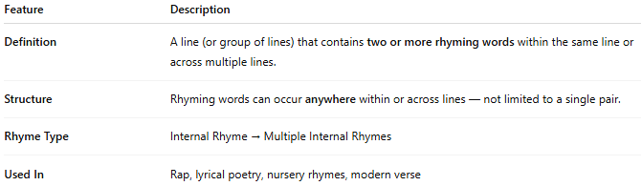
Feature | Description
Definition | A line (or group of lines) that contains two or more rhyming words within the same line or across multiple lines.
Structure | Rhyming words can occur anywhere within or across lines — not limited to a single pair.
Rhyme Type | Internal Rhyme → Multiple Internal Rhymes
Used In | Rap, lyrical poetry, nursery rhymes, modern verse

📝 Examples:
# Source: Chatgpt (GPT-4-turbo) at [8/2/2025]
The bright night light gave him a fright.
She glared, then dared, and left them all scared.
With a sigh and a cry, he tried to deny the lie.
Here, multiple internal rhymes (e.g., bright–light–fright, glared–dared–scared) appear in one line or tightly grouped lines.

🎭 Effect in Poetry and Music:
# Source: Chatgpt (GPT-4-turbo) at [8/2/2025]
- Intensifies musicality and flow
- Builds rhythmic complexity
- Enhances emphasis and emotional intensity
- A hallmark of rap and slam poetry

✅ When to Use:
# Source: Chatgpt (GPT-4-turbo) at [8/2/2025]
- To create dense sonic texture
- To speed up rhythm or emphasize energetic tone
- To make language feel dynamic, layered, or hypnotic

